2018 Offering of Letters
For Such a Time as This
The story of Esther in the Old Testament provides us with a challenging example of courageous advocacy for people under threat. The Persian king had ordered the killing of the Jewish people, and Queen Esther's cousin Mordecai urged her to approach the king on behalf of her people, at great personal risk. Mordecai reasoned that it was "for such a time as this" that God had intervened in history to allow Esther to rise to her privileged position.

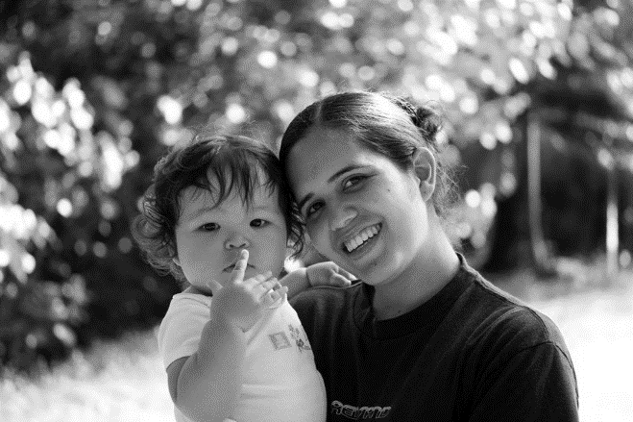
​What about us? We live in a democracy and have the right to communicate to our elected officials on behalf of our brothers and sisters. Perhaps now more than ever, we have a responsibility to exercise that right.

Every day, millions of people in the United States and around the world feed and support their families through lifesaving programs that we Americans fund through our federal
government. Our investments have contributed to tremendous progress toward ending hunger.
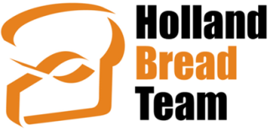
Globally, hunger has been cut in half over the past 25 years, though violent conflicts have recently reversed some of that progress.

Here in the United States, 1 in 8 Americans lives with the risk of hunger. Many of our nation’s hungry are children or senior citizens. Locally, the problem of food insecurity is worsened by a shortage of affordable housing.

Our parish’s support of the St. Vincent Center and Kids’ Food Basket provides valuable help to our neighbors, but these efforts only supplement the far more comprehensive help provided by federal programs such as SNAP (food stamps) and school lunches. Similarly, though our support of the Catholic Relief Services Collection is a valuable means of reaching needy people in other nations, these faith-based efforts are no replacement for our nation’s international aid.

Despite the importance of our nation’s programs for hungry people, the administration and many members of Congress are calling for deep cuts in both domestic assistance programs and poverty-focused international aid.

Similar cuts were proposed last year, but we need not despair. Bread for the World President David Beckmann assures us:

“As part of the 2017 Offering of Letters, Bread for the World members led the way in preventing cuts to crucial programs. This year, we have a real chance to get our nation and the world on track to end hunger.”

Letters will be available to sign after the Masses of May 19/20. See bread.org/OL for more information about this year’s offering. Also, to learn about the Holland Bread Team, see HollandBreadTeam.org or its Facebook page.

