2019 Offering of Letters

Better Nutrition,
Better Tomorrow
Thanks to recent progress on targeting food aid for maximum impact, Rodgers, a small child in Uganda, is on his way to growing up healthy and strong. We now know that providing proper nutrition to children during the first 1,000 days of life (pregnancy through age 2) can make the difference between a lifetime of poor health and a lifetime of vigor. Such nutritional improvements have far reaching effects for entire societies, since healthier individuals are more productive and have healthier families.

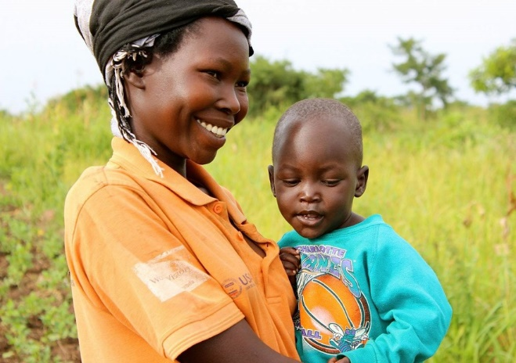​

Success stories like that of Rodgers help us to realize that hunger is not inevitable; it exists because we allow it. Moreover, although the world has made great strides toward reducing hunger over the last few decades, recent years have seen increases in hunger, due to war and other disasters.

This reversal in our overall progress can and must be corrected. That is why this year’s Offering of Letters is asking members of Congress to take the following actions.
- Scale up cost-effective, proven programs such as investing in nutrition for pregnant mothers and their young children.
- Protect and increase funding for global nutrition.
Is not this the kind of fasting I have chosen: to loose the chains of injustice and untie the cords of the yoke; to set the oppressed free and break every yoke? Is it not to share your food with the hungry? Then your light will break forth like the dawn, and your healing will quickly appear. Isaiah 58:6, 7a, 8a
During this season of Lent, we are called to prayer, fasting, and almsgiving—all practices that can move us toward greater solidarity with hungry people. The CRS Rice Bowl, Kids’ Food Basket, and the St. Vincent Center provide opportunities to help alleviate hunger. However, we must also address the causes of hunger. Sending letters to Congress is one step toward fulfilling this second responsibility.
Letters will be available to sign after the Masses of March 23/24. See bread.org/OL for more information about this year’s offering or www.stfrancisholland.org/bread for copies of our form letters. Also, to learn about the Holland Bread for the World Team, see HollandBreadTeam.org.
