2020 Offering of Letters

Better Nutrition,
Better Tomorrow
“Increased funding for nutrition is the smartest and most cost-effective investment to save lives, promote peace, and enhance sustainability.”
--William Frist, surgeon and former US Senate Majority Leader
This year’s Offering of Letters (letter-writing campaign) builds upon last year’s request that Congress affirm the need for strong US leadership in providing global nutrition. Last January the Senate fulfilled our 2019 request by unanimously passing a Global Nutrition Resolution! In 2019 the House also introduced a Global Nutrition Resolution, which (though not yet passed) has garnered 153 co-sponsors, including Representative Bill Huizenga whose district includes Ottawa County.

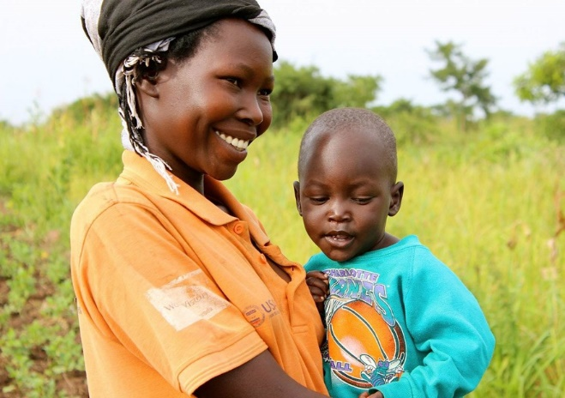​

This year we want Congress put money behind its resolutions: we are requesting that the budget for international nutrition programs be increased from $150 million in the current year to $200 million next year, and we are asking for $50 million to fund a Summer Electronic Benefits Transfer (EBT) program. The Summer EBT program provides additional resources to families who rely on free and reduced-price school meals during the school year.
In addition to causing human misery, hunger incurs staggering costs. It raises health-care costs, stifles economies, and leads to unrest and extremism. Conversely, improving access to proper nutrition reaps generous rewards by averting the myriad of problems associated with hunger.
In recent decades, the world has made tremendous strides against hunger. Since 1990 our world has cut hunger roughly in half. Moreover, we know much more about effective ways to reduce hunger than we did just two decades ago. God is indeed working in our time! Our advocacy is a way of cooperating with God’s grace and a means of fulfilling our responsibility to respect life.
Letters will be available to sign after the Masses of March 14/15. See bread.org/OL for more information about this year’s offering, www.stfrancisholland.org/bread for copies of our form letters, or HollandBreadTeam.org to learn more about Holland Bread for the World.
